The Three-Sector Model
The three-sector model in economics divides economies into three sectors of activity: extraction of raw materials (primary), manufacturing (secondary), and services (tertiary). It was developed by Allan Fisher, Colin Clark and Jean Fourastié.
According to the model, the main focus of an economy's activity shifts from the primary, through the secondary and finally to the tertiary sector. Fourastié saw the process as essentially positive, and in The Great Hope of the Twentieth Century he wrote of the increase in quality of life, social security, blossoming of education and culture, higher level of qualifications, humanisation of work, and avoidance of unemployment.
Countries with a low per capita income are in an early stage of development; the main part of their national income is achieved through production in the primary sector. Countries in a more advanced state of development, with a medium national income, generate their income mostly in the secondary sector. In highly developed countries with a high income, the tertiary sector dominates the total output of the economy.
The following figure illustrates the percentages of a country’s economy made up by different sector. The figure illustrates that countries with higher levels of socio-economic development tend to have less of their economy made up of primary and secondary sectors and more emphasis in tertiary sectors. The less developed countries exhibit the inverse pattern.
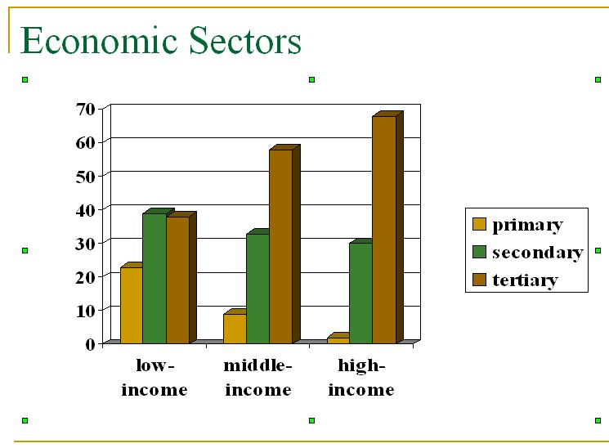

Structural transformation according to Fourastié
The distribution of the workforce among the three sectors progresses through different stages as follows, according to Fourastié:

First phase: Traditional civilizations

Workforce quotas:
- Primary sector: 64.5%
- Secondary sector: 20%
- Tertiary sector: 15.5%
This phase represents a society which is scientifically not yet very developed, with a negligible use of machinery. The state of development corresponds to that of European countries in the early Middle Ages, or that of a modern-day developing country.

Second phase: Transitional period
Workforce quotas:
- Primary sector: 40%
- Secondary sector: 40%
- Tertiary sector: 20%
More machinery is deployed in the primary sector, which reduces the number of workers needed. As a result, the demand for machinery production in the secondary sector increases. The transitional way or phase begins with an event which can be identified with the industrialisation: far-reaching mechanisation (and therefore automation) of manufacture, such as the use of conveyor belts.
The tertiary sector begins to develop, as do the financial sector and the power of the state.

Third phase: Tertiary civilization
Workforce quotas:
- Primary sector: 10%
- Secondary sector: 20%
- Tertiary sector: 70%
The primary and secondary sectors are increasingly dominated by automation, and the demand for workforce numbers falls in these sectors. It is replaced by the growing demands of the tertiary sector. The situation now corresponds to modern-day industrial societies and the society of the future, the service or post-industrial society. Today the tertiary sector has grown to such an enormous size that it is sometimes further divided into an information-based quaternary sector, and even a quinary sector based on human services.
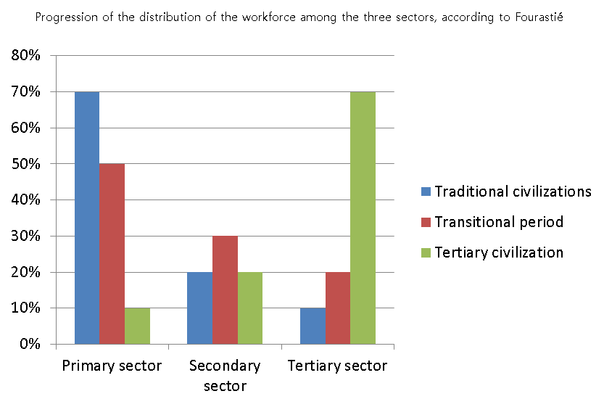

Sectors of economy on the basis of economic activity
Primary sector
An industry involved in the extraction and collection of natural resources, such as copper and timber, as well as by activities such as farming and fishing. A company in a primary industry can also be involved in turning natural resources into products. Primary industries are also known as agriculture sector. Primary industry tends to make up a larger portion of the economy of developing countries than they do for developed countries. The primary sector is concerned with the extraction of raw materials. It includes fishing, farming and mining.
Primary industry is a larger sector in developing countries; for instance, animal husbandry is more common in countries in Africa than in Japan.
In developed countries the primary industry has become more technologically advanced, for instance the mechanization of farming as opposed to hand picking and planting.
Secondary sector
The secondary sector of the economy includes industries that produce a finished, usable product or are involved in construction.
This sector generally takes the output of the primary sector and manufactures finished goods or where they are suitable for use by other businesses, for export, or sale to domestic consumers. This sector is often divided into light industry and heavy industry. Many of these industries consume large quantities of energy and require factories and machinery to convert raw materials into goods and products. They also produce waste materials and waste heat that may cause environmental problems or cause pollution. The secondary sector supports both the primary and tertiary sector.
Manufacturing is an important activity to promote economic growth and development. Nations that export manufactured products tend to generate higher marginal GDP growth which supports higher incomes and marginal tax revenue needed to fund the quality of life initiatives such as health care and infrastructure in the economy. The field is an important source for engineering job opportunities. Among developed countries, it is an important source of well-paying jobs for the middle class to facilitate greater social mobility for successive generations on the economy.
Tertiary sector
The tertiary or the service sector consists of the production of services instead of end products. Services (also known as "intangible goods") include attention, advice, access, experience, and affective labour. The production of information has long been regarded as a service, but some economists now attribute it to a fourth sector, the quaternary sector.
The tertiary sector of industry involves the provision of services to other businesses as well as final consumers. Services may involve the transport, distribution and sale of goods from producer to a consumer, as may happen in wholesaling and retailing, pest control or entertainment. The goods may be transformed in the process of providing the service, as happens in the restaurant industry. However, the focus is on people interacting with people and serving the customer rather than transforming physical goods.

