Physiography of North East India
Geology
North East India consists of three geological structural units –
- The Karbi-Meghalaya Plateaus of the Pre-Cambrian period
- The Himalayan Mountain of the Tertiary period
- The Brahamaputra Plain of the of the Tertiary period
The geological structure of the region is reflected on the physiography too as mentioned below.
Physiography: Relief
Physiographically the North East can be divided into the following three divisions:
- The Plateau Region
- The Hills and Mountains
- The Plains
The Plateau Region – The Karbi-Meghalaya Plateau forms the core of the region, is in fact, an extension of the Deccan Plateau. The latter extends underground from the Rajmahal Hills of Chotanagpur Plateau below Malda districts of West Bengal and Rajshahi, Dinajpur and Rangpur districts of Bangladesh and appears in the North East above the surface as Meghalaya Plateau and Karbi Hills.
It is believed that a downward created the Malda-Rangpur gap which was subsequently filled up by the alluvial deposits of the Brahmaputra and the Ganges.
The apparently detached Meghalaya and Karbi Plateaus are now 402.2 km long from the Singimari river in the west to the Dhansiri river in the east. The unit’s average width is about 80 km and covers an area of 32, 829 km². The plateaus are high in the middle (attaining a height of 1961 m) and low towards the west and east. Further, the plateaus can be divided into two units –
- The Meghalaya Plateau, comprising the Garo, Khasi and Jaintia Hills, and
- The Karbi Plateau, comprising the Karbi and Rengma Hills.

- The Meghalaya Plateau – it is traditionally divided into Garo, Khasi and Jainita Hills. Garo Hills in the west is a relatively low and more dissected part. The area of this part is 7769.9 km². Although its average height is 900 m, the Garo plateau rises to a distinct east-west range known as the Tura Range or Kylas Range just south of Tura. This range is higher than 1100 m and reaches its highest point at Mount Nokrek (1529 m).
To the east of the Garo Hills lie the higher Khasi Hills. This is the highest part of the Meghalaya Plateau with an average height of about 1066 m. However, its central upland covering an area of 1250 km² is still higher and reaches a general height of 1400 m. There runs in this highland an east-west range known as the Shillong Range with its highest peak reaching 1961 m.
The easternmost part of the Meghalaya Plateau is the Jaintia Hills. It consists of Jaintia Hills district of Meghalaya and Hamren sub-division of Karbi Anglaong district. This part of the plateau slopes down from Khasi Hills from 1200 m to about 500 m in the east, the average height being 900 m. Its area is about 3790 km².

- The Karbi Plateau – it is the easternmost part of the north-eastward projection of the Gonwanaland, lies almost detached from the Meghalaya plateau due to headward erosion of the Kapili and Dhansiri rivers and their tributaries. It is pear-shaped and has an area of about 7000 km². To its south lie the young folded ranges of North Cachar Hills and to the North the Brahmaputra river.

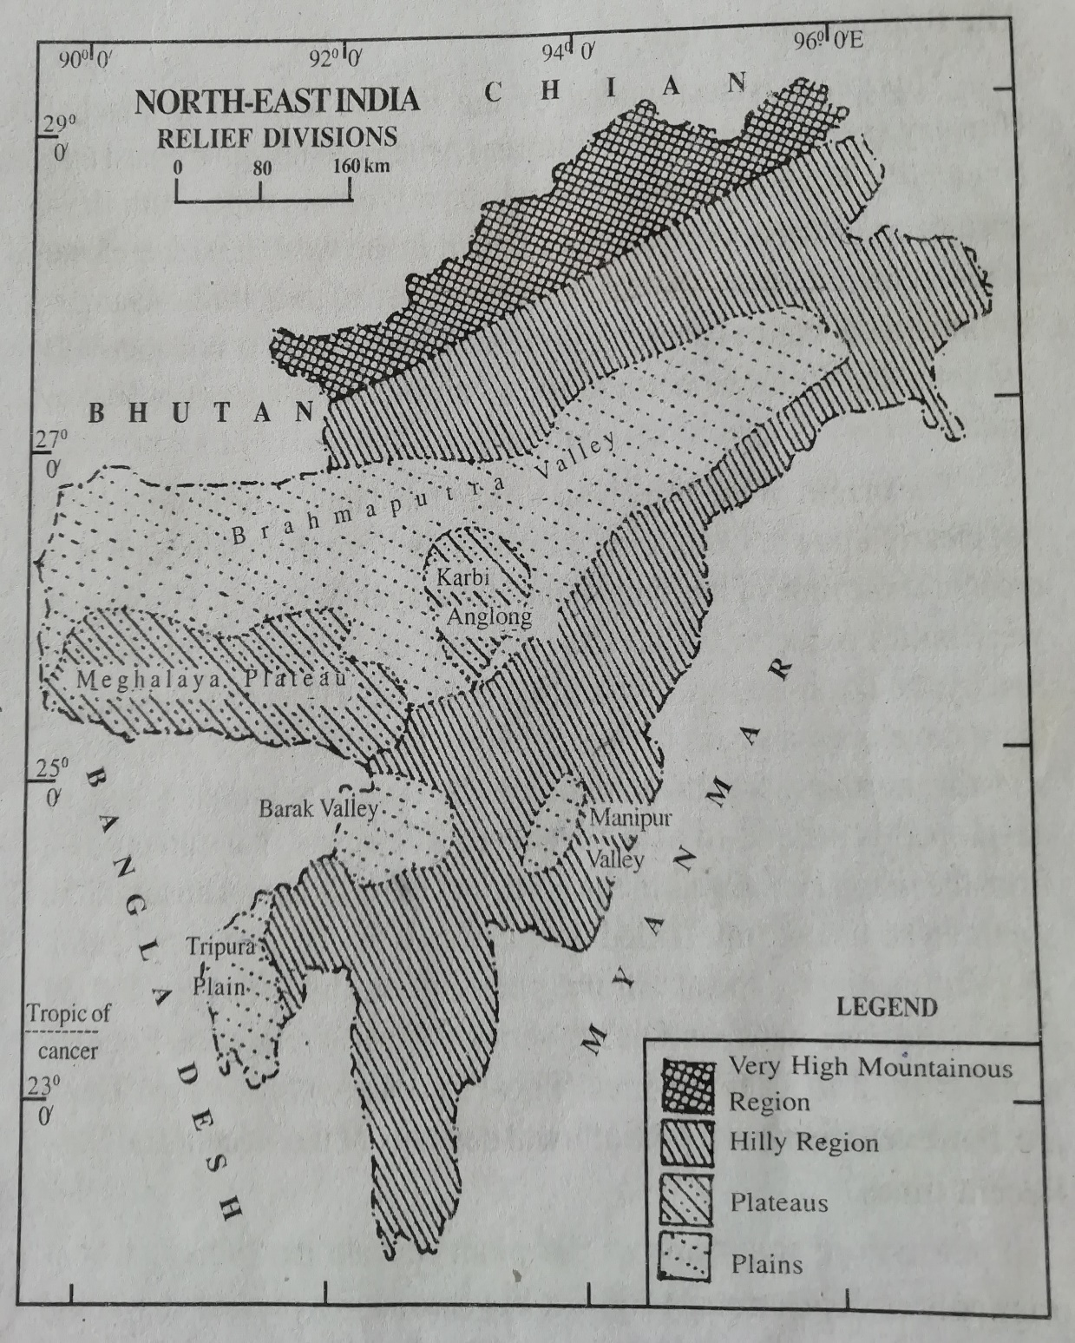

Physiography – Relief Division of North East India

