Rural India is far behind Urban India in every Indicator of Progress

The India Vs Bharat debate is not new. The Urban –Rural divide has been debated for years together. There seems to be little progress made over the last seven decades in bridging this gap. The gap only seems to be widening by the day. Here is a look at some of the important socio-economic indicators in Urban & Rural India.

“India lives in villages” were the golden words of Mahatma Gandhi many decades ago. Ironically after almost 50 years the data does not seem to disagree. Today a majority of the Indian population still live in the villages. Though there is substantial migration from rural to urban areas in India, still almost 68% of India continues to live in rural areas.

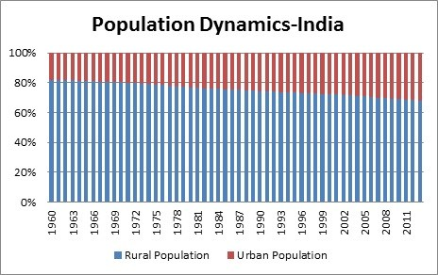

The socio-economic census data (2011) released very recently said that almost 73% of the households were in rural areas. On the contrary, India’s vision today is highly urban centric. Cities are tipped to be the catalysts of growth in the future. One fears the decay of villages and therefore there is a need to visit the existing ground realities. This piece looks at various indicators of socio-economic progress in India from the rural-urban perspective.

The GDP Composition over time
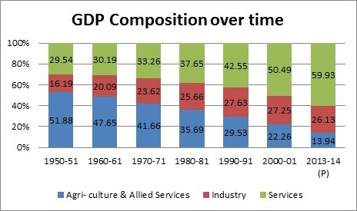

Rural Livelihood & Employment
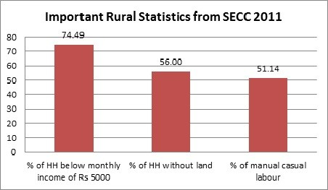
Poverty Estimates
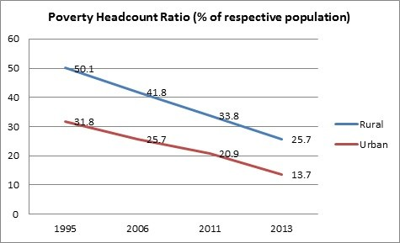
Literacy Levels
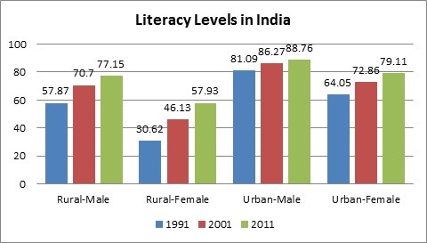

Literacy Rate of SCs & STs
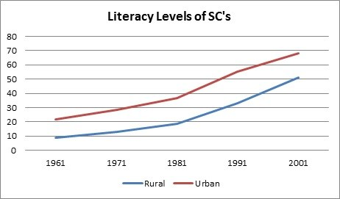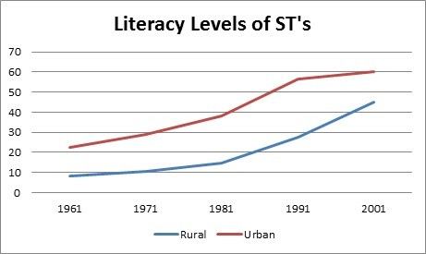
Net Attendance – Rural Vs Urban
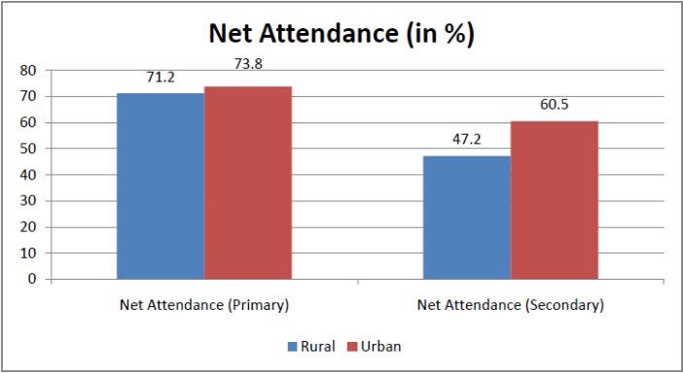

Health Indicators – The same story continues
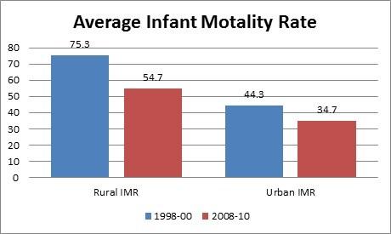
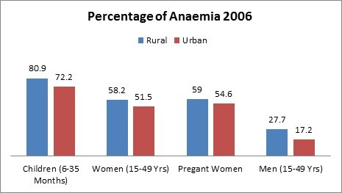
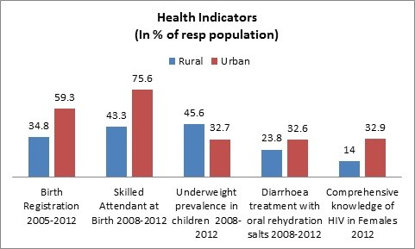
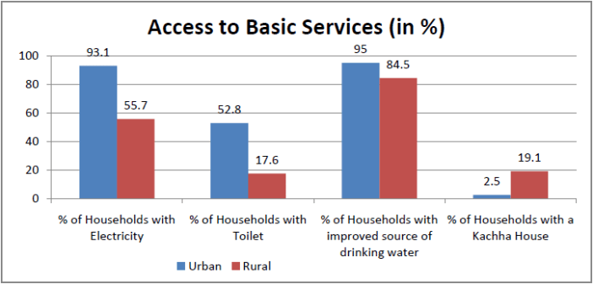

Rural India always takes a backseat
Today, after almost 7 decades of independence, the existing policy dynamics has taken a toll on rural India. The villages take a backseat in almost every aspect of socio-economic analysis. We have created an economy of rich cities and poor villages, surging urban areas and decaying rural areas. The current government at the centre came to power with a thumping majority with its primary objective being “Sab Ka Saath Sab Ka Vikaas”, which translates to “Taking everybody along and development for all”. One can only hope that this becomes a reality and for that to happen a balance between urban and rural development is a definite prerequisite.

Source: FACTLY online journal

