MA (q) Process Basic Concepts

A q-order moving average process, denoted MA(q) takes the form

Thinking of the subscripts i as representing time, we see that the value of y at time i+1 is a linear function of past errors. We assume that the error terms are independently distributed with a normal distribution with mean zero and a constant variance σ². Thus
Observation: An MA(q) process can be expressed as
where z_{i} = yi – μ. Thus, we can often simplify our analyses by restricting ourselves to the case where the mean is zero.
Using the lag operator, we can express a zero mean MA(q) process as
Where
,
defines a linear combination in the shift operator L^{q} ε_{i} = ε_{i-q}

Property 1: The mean of an MA(q) process is μ.

Proof:

Property 2: The variance of an MA(q) process is

Proof:

Property 3: The autocorrelation function of an MA(1) process is
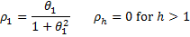
Proof:

When h = 1

since E[εi₋₁] = 0.

When h > 1
Thus for h = 1, by Property 2

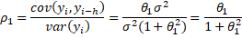
and for h > 1
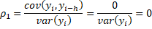

Property 4: The autocorrelation function of an MA(2) process is

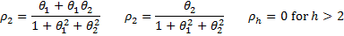
Proof:

Thus, when h = 1

and when h = 2
and when h > 2

It now follows that for h = 1, by Property 2
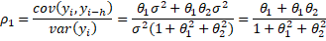
and for h = 2
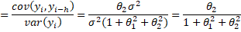
and for h > 2

Calculating MA Coefficients using ACF

If we know (or assume) that a time series can be fit by an MA(q) process, then we need to figure out the value of the parameters μ, σ², q, θ₁, …, θ_{q}. The initial approach to determining the value for q is to look at the ACF values for the time series under consideration. Since we know that for an MA(q) process, ρ_{k} = 0 for all k > q, we seek the first value for q where ACF(q) is approximately zero.
We next turn our attention to finding the other parameters that provide the best fit for the data. We start by looking at an MA(1) process
yi = μ + ε_{i} + θ₁ε_{i-1} .
We know that
Property 1: The mean is μ.
Property 2: The variance is
Property 3: The autocorrelation function is
We start by using the mean of the time series as μ. We then subtract this value from all the time series values to get a zero mean time series. We then calculate the variance s² and r = ACF(1) of the time series. We can solve for θ₁ using the equation
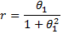
which is equivalent to the quadratic equation
which has the solutions
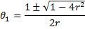
Actually θ₁ above is really the estimated value of θ₁ which typically has a hat over it. These solutions are real provided |r| < .5. It turns out that for large values of n

where
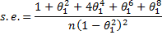
Also note that
