The Theme of Culture Region
Places provide the main stuff of geography. How and why are places alike or different? How are their inhabitants perceive and identify with then? These are all essential geographical questions. Region is the word and concept used by geographers to mean a grouping of like places or the functional union of places to form a spatial unit. Maps are an essential tool used to describe and reveal regions. If, as is often said, one picture is worth a thousand words, then a well-prepared map is worth at least ten thousand words to the geographer. No description in words can rival the descriptive force of maps. Maps are valuable tools particularly because they so concisely portray special patterns in culture. Three types of regions are recognized by cultural geographers.
Formal Culture Regions. A formal culture region can be defined as a uniform area inhabited by people who have one or more cultural traits in common. If cultural geography, above all, is a celebration of human diversity in the spatial dimension, then the formal culture region is a depiction of that mosaic. You cannot go into the street and find a formal culture region, yet there is nothing mysterious about it. Geographers find the formal culture region useful for grouping people with similar cultural traits. For example, a Tamil/Hindi-language culture region can be drawn on a map of languages, and it would include the area where Tamil/Hindi is spoken.
The example of Tamil/Hindi speech and wheat cultivation represent the concept of formal region at the simplest level. Each is based on a single cultural trait. More commonly, culture regions depend on multiple related traits. Thus an Eskimo culture region might be based on language, religion, type of economy, type of social organization, and typical form of dwellings. The culture region would reflect the spatial distribution of these five Eskimo cultural traits. Districts where all five of these traits are present would be part of the culture region.
Formal culture regions are the geographer’s somewhat arbitrary creations. No two cultural traits have the same distribution and the territorial extent of a culture region depends on what defining traits are used. For example, Greeks and Turks differ in language and religion. Culture regions defined on the basis of speech and religious faith would separate these two groups. However, Greeks and Turks hold many other cultural traits in common, partly because of the long Turkish rule of Greece and the lengthy coexistence of Greeks and Turks in Asia Minor. Both groups are monotheistic, worshipping a single god. In both groups, male supremacy and patriarchal families are the rule. Certain folk foods, such as shish kebab, are enjoyed in common. Whether Greeks and Turks are placed in the same formal culture region or in different ones depends entirely on how the geographer chooses to define the culture region. That choice in turn depends on the specific purpose of research or exposition that the culture region is designed to serve. Thus, an infinite number of formal culture regions can be created. It is unlikely that any two geographers would use exactly the same distinguishing criteria.
Often cultural geographers attempt to delimit culture regions based on the totality of traits displayed by a culture. The term culture area is sometimes used for such regions. Because of the greater complexity of traits involved, culture areas are typically even more arbitrarily delimited than are formal regions

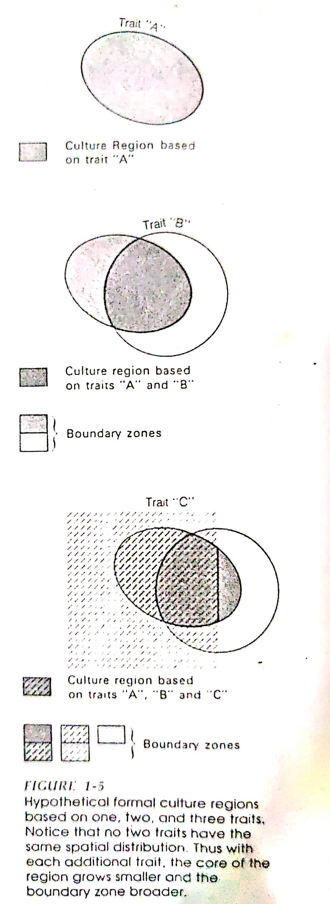

based on fewer characteristics. Often, they are based more on the geographer’s intuition, derived from intimate knowledge of an area, than on carefully arranged facts.
The geographer who identifies a formal culture region or area must locate cultural borders. Because culture are fluid, such boundaries are rarely sharp, even if only a single culture trait is being mapped. For this reason, geographers often speak of cultural border zones rather than lines. Naturally, these zones broaden with each additional cultural trait that is considered, because no two traits have the same spatial distribution.
No matter how closely related two elements of culture seem to be, careful investigation always shows that they do not exactly cover the same area. This is true regardless of what degree of detail is involved. Thus, just as the map of languages does not duplicate the distribution of religions, governments, or economies, so also no two words or pronunciations within a single dialect or language cover precisely the same area.
What does this mean to the cultural geographer in practical terms? First, it means that every feature and detail of culture is unique to an area and that the explanation for each spatial variation is different in some degree from those for all other cultural phenomena. Second, it means that culture changes continually through an area, and that every inhabited place on the Earth has a unique combination of cultural features, differing from other place in one or more respects.
Functional Culture Regions. A functional culture region is quite different from a formal culture region. The hall mark of the formal type is cultural homogeneity, and the formal culture region is abstract rather than concrete. By contrast, the functional culture region is generally not culturally homogenous. Instead, it is an area that has been organized to function politically, socially, or economically. A city, an independent state, a precinct, a church diocese or parish, a trade area, a farm, and a Federal Reserve Bank district are all examples of functional regions. Functional culture regions have nodes, or central points where the functions are coordinated and directed. Examples of such nodes, or central points where the functions are coordinated and directed. Examples, of such nodes are city halls, national capitals, precinct voting places, parish churches, factories, farmsteads, and banks. In this sense, functional regions also possess a core/periphery configuration, in common with formal regions.
Some functional regions have clearly defined borders and are concrete units. A farm is functional region that includes all land owned or leased by the farmer. Its operation is directed by the farmer, who has organized the land to function as a distinct spatial unit. The node is the farmstead, which contains the home of the farmer and various structures essential to farming, such as barns, implement sheds, and silos. The borders of this functional region will probably be clearly marked by fences, hedges, or walls. Similarly, each state in the United States is a functional region, coordinated and directed from the state capital and extending government control over a fixed area with clearly defined borders.
Vernacular Culture Regions. Geographers recognize a third type of culture region, the vernacular, popular or perceptual. This is a region perceived to exist by its inhabitants, as evidenced by the widespread acceptance and use of a regional name. Figure A shows a visible expression of such region. Some vernacular regions are based on physical environmental features, while others find their basis in economic, political, historical, or promotional aspects. Vernacular regions, like most culture regions, generally lack sharp borders, and the inhabitants of any given area may claim residence in more than one such region. These perceived regions are often created by publicity campaigns, and their use in the communications media has a lot to do with acceptance by the local populations.
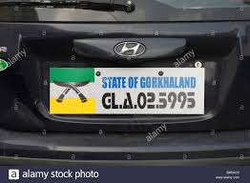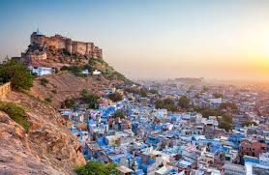

The element of regional self-consciousness, through which people are aware of their regional identity and endow it with symbols and emotions, is inherent in the vernacular type of region. By contrast, many formal or functional regions lack this attribute and are, as a result, far less potent geographical entities. Self-conscious regional identity can have major political and social ramifications.
Vernacular culture regions, as one understands are rather different from the functional or formal types. They often lack the organization necessary for functional regions, though often they are centred on a single urban node, and they frequently do not display the cultural homogeneity that characterizes formal regions. They are a type unto themselves, a type rooted in the popular or folk culture.

