Interior of the Earth
Though the study of constitution of the interior of the earth is outside the domain of geography but its elementary knowledge is necessary for the geographers because the nature and configuration of the reliefs of the earth’s surface largely depend on the nature, mechanism and magnitude of the endogenetic forces which originate from within the earth.
It is decidedly true that it is very difficult task to have accurate knowledge of the constitution of the earth’s interior because it is beyond the range of direct observation by man but recently seismology has helped to have some authenticated knowledge about the mystery of the earth’s interior. The sources which provide knowledge about the interior of the earth may be classified into 3 groups:
- Artificial sources
- Evidences from the theories of the origin of the earth
- Natural sources (e.g. volcanic eruption, earthquakes and seismology)
Evidence of Seismology
Seismology is the science which studies various aspects of seismic waves generated during the occurrence of earthquake. Seismic waves are recorded with the help of an instrument known as seismograph. It may be pointed out that seismology is the only source which provides us authenticated information about the composition of earth’s interior.
The place of occurrence of an earthquake is called ‘focus’ and the place which experiences the seismic event first is called ‘epicentre’, which is located on the earth’s surface and is always perpendicular to the ‘focus’. On the other hand, the focus or the place of the origin of an earthquake is always inside the earth. The deepest focus has been measured at the depth of 700 km from the earth’s surface. The different types of tremors and waves generated during the occurrence of an earthquake are called ‘seismic waves’ which are generally divided in 3 broad categories e.g. primary waves, secondary waves and surface waves.
- Primary waves also called as longitudinal or compressional waves or simply ‘P’ waves, are analogous to sound waves wherein particles move both to and fro in the line of the propagation of the ray. P waves travel with fastest speed through solid materials. Though these also pass through liquid materials, but their speed is slowed down.
- Secondary waves are also called as transverse or distortional or simply S waves. These are analogous to water ripples or light waves wherein the particles move at right angles to the rays. S waves cannot pass through liquid materials.
- Surface waves are also called as Long Period waves or simply L waves. These waves generally affect only the surface of the earth and die out at smaller depth. These waves cover the longest distance of all the seismic waves. Though their speed is lower than P and S waves but these are most violent and destructive.
When an earthquake occurs, the seismic waves are recorded at the epicentre with the help of seismograph. In the beginning a few small and weak swings are recorded. Such tremors are called ‘first preliminary tremors’. After a brief interval the ‘second preliminary tremors’ are recorded and finally the ‘main tremors’ of strong waves are recorded.

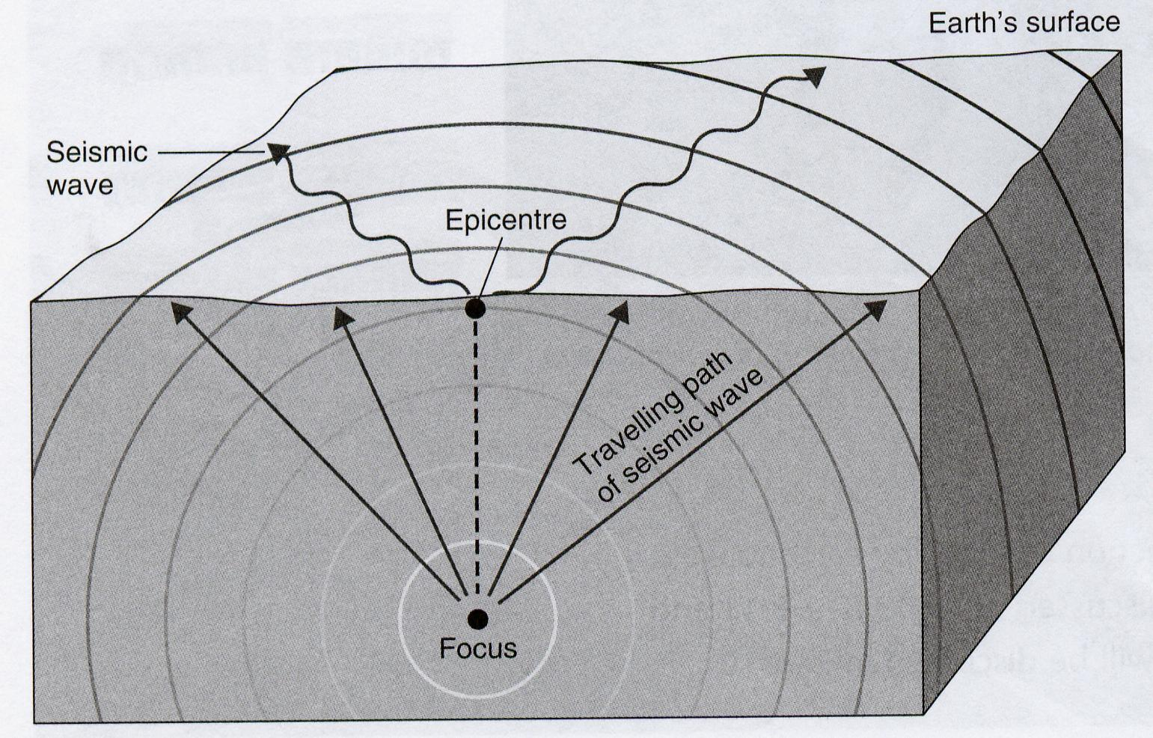
The nature and properties of the composition of the interior of the earth may be successfully obtained on the basis of the study of various aspects of seismic waves mainly the velocity and travel paths of these waves while passing through a body having heterogenous composition and varying density zones. If the earth would have been composed of homogenous solid materials the seismic waves should have reached the core of the earth in a straight path but this is not the case in reality. In fact, the recorded seismic waves denote the fact that these waves seldom follow straight paths rather they adopt curved and refracted paths. Thus, it becomes obvious that the earth is not composed of homogenous materials rather there are variations of density inside the earth. The seismic waves are refracted at the places of density changes. A regular change of density inside the earth causes a curved path to be followed by the seismic waves. Thus, the seismic waves become concave towards the earth’s surface.
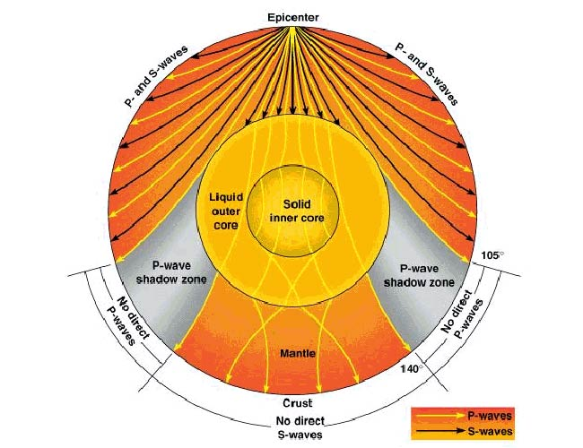
As stated earlier S waves cannot pass through liquid. After in depth study of seismic waves Oldhum demonstrated in the year 1909 that S waves disappear at an angular distance of 120° from the epicentre and P waves are weakened. It is evident from the diagram that S waves are totally absent in the core of the earth. It appears from this observation that there is a core in liquid state which is located at the depth of more than 2900 km from the earth’s surface and surrounds the nucleus of the earth. Based on this finding the scientists have estimated that the iron and nickel of the core of the earth may be in liquid state.
Not only this, if we study the nature, characteristics and velocity of seismic waves, we may find the presence of several density zones inside the earth.
On the basis of changes of velocity of seismic waves it is proved that there are major changes in the velocity of waves at three places inside the earth and hence it can be safely inferred that there are three distinct zones or layers of varying densities in the earth:
- Crust – the average density of the outer and lower crust is 2.8 and 3.0 respectively. The difference of density between the upper crust (2.8) and lower crust (3.0) is because of the pressure of supper incumbent load. The formation of the minerals of the upper crust was accomplished at relatively lower pressure than the minerals of the lower crust.
- Mantle – there is sudden increase in the velocity of seismic waves at the base of lower curst as the velocity of seismic waves is about 6.9 km per second, but it suddenly becomes 7.9 to 8.1 km per second. This trend of seismic waves denotes discontinuity between the boundaries of lower crust and upper mantle. This discontinuity was discovered by A. Mohorovicic in the year 1909 and thus it is called as ‘Mohorovicic Discontinuity’ or simply ‘Moho Discontinuity’. The mantle having a mean density of 4.6 extends for a depth of 2900 km.
It may be mentioned that the thickness of the mantle is less than half of the radius of the earth (6371 km) but it contains 83 percent of the total volume and 68 percent of the total mass of the earth.
The mantle is divided into 3 sub-zones –
- First zone extending from Moho Discontinuity to 200 km depth
- Second zone extending from 200 km to 700 km depth and
- Third zone extending from 700 km to 2900 km depth.
The velocity of seismic waves relatively slows down in the uppermost zone of the upper mantle. This zone is called the zone of low velocity.
Mantle is believed to have been formed largely of silicate minerals rich in iron and magnesium.
- Core – the core, the deepest and most inaccessible zone of the earth, extends from the lower boundary of the mantle at the depth of 2900 km to the centre of the earth (up to 6371 km). The mantle-core boundary is determined by the ‘Weichert-Gutenberg Discontinuity’ at the depth of 2900 km. It is significant to note that there is pronounced change of density from 5.5 to 10 along the Gutenberg Discontinuity. This sudden change in density is indicated by sudden increase in the velocity of P waves along the mantle-core boundary or Gutenberg Discontinuity. The density further increases from 12.3 to 13.3 and 13.6 with increasing depth of the core. It, thus, appears that the density of the core is more than twice the density of the mantle but the volume and mass of the core are 16 per cent and 32 per cent of the total volume and mass of the earth respectively.
The core is further divided into two sub-zones e.g. outer core and inner core, the dividing line being at the depth of 5150 km. S waves disappear in this outer core. This means that the outer core should be in molten state. The inner core extends from the depth of 5150 km to the centre of the earth (6371 km). This lowermost zone of the interior of the earth is in solid state, the density of which is 13.3 to 13.6. It is generally believed that that the core is composed of iron and nickel.

