Bottom Relief of the Oceans
Shape and Size
The Pacific Ocean covering one-third of the area of the earth, extends from the coast of Asia in the west to America in the east (16093 km) and rom Bering Strait in the north to the Cape Adare (Antarctica Continent) in the South (14966 km). The average depth of the Pacific is about 5000 m. Only 3.9 % of its area is less than 1000 m. deep whereas major portion (30.9 %) lies below 5000 m. excluding adjacent seas. The descent from the coast to the sea plain is very much steeper. The oceanic surface in general is uniform, with broad gentle swells and depressions. Maximum area of 37.7 % lies within 4000-5000 m. depth.
It is the most unique ocean in many respects. It has a broad triangular shape. All along the coast for nearly 17700 km, the folded mountains are found parallel to it. In the north, it is completely blocked excepting a narrow Bering Sea passage into the Arctic Ocean.
Continental Shelf
The continental shelf surrounding the margin of the Pacific Ocean is controlled by the shape and structure of its coastline. On the eastern margin of this ocean the width of the shelf is rather narrow. Due to the presence of the Rockies and the Andes Mountains parallel to the west coasts of North and south Americas respectively the continental shelves have become very narrow. Their width is limited to only 80 km.
However, on the western margin of this ocean, due to the absence of mountain chains or plateaus, the continental shelf is broad. The continental shelves adjoining the coasts of Australia, East Indies and East Asia are relatively much broader. Along these coasts the width of the shelves varies from 160 to 1600 km with their average depth hardly exceeding 1000 m. On these shelves are situated most of the islands and marginal seas.
Ridges
Pacific Ocean is different from the other oceans in the respect that it has no central ridge. Only a few submarine ridges can be located here and there, mostly on the eastern margin of the ocean, and the submarine swells are found in the middle of the Pacific. One of the most important ridges known as the East Pacific ridge or Albatross Plateau (3000-4000 m. deep) is quite extensive. The north-east projection of the plateau is known as Cocos ridge and extends from the coast of Central America towards south-west. It is about 1600 km broad and bifurcates into two near 2◦ S lat. The eastern part is a narrow ridge named San Felix-Juan Fernandez ridge, less than 2000 m. deep and runs parallel to the Chilean coast. The western ridge moves to the south and forms a wide plateau between 20◦-40◦S lat., known as South-Eastern Pacific plateau. The depth here is between 2000-4000m. Further south the same plateau narrows down in the form of a curved Pacific-Antarctic ridge where the depth is about 3500 m.
Basins
Many depressions and basins, separated by numerous swells, are also found in the Pacific Ocean.
- Aleutian basin – north of the Aleutian island, this basin is 4000 m. deep.
- Philippine basin – situated east of Philippine Islands, this basin extends up to 5◦ N. Its depth varies between 5000-6000 m. The western part of the basin is comparatively deeper than 6000m.
- West Caroline basin. It is a 4000-5000 m. deep circular basin east of Philippine basin.
- East Caroline basin – this basin is also 5000 m. deep.
- Fiji basin – south of Fiji Island, Fiji basin is more than 4000 m.
- East Australian basin – a 4000 m. deep basin, compact and circular in form, extends east of Australia with areas deeper than 5000 m. found in the north.
- South Australian or Jeffrey’s basin – it is a 5000 m. longitudinal basin extending south of Australia.
- South-western Pacific basin – it is a wide 6000 m. deep basin.
- South-eastern Pacific basin – this 5000 m. deep and broad basin extends west of Peru and Chile with Baver deep of 5266 m. depth.
- Pacific Antarctic basin. It extends south-west of Chile.
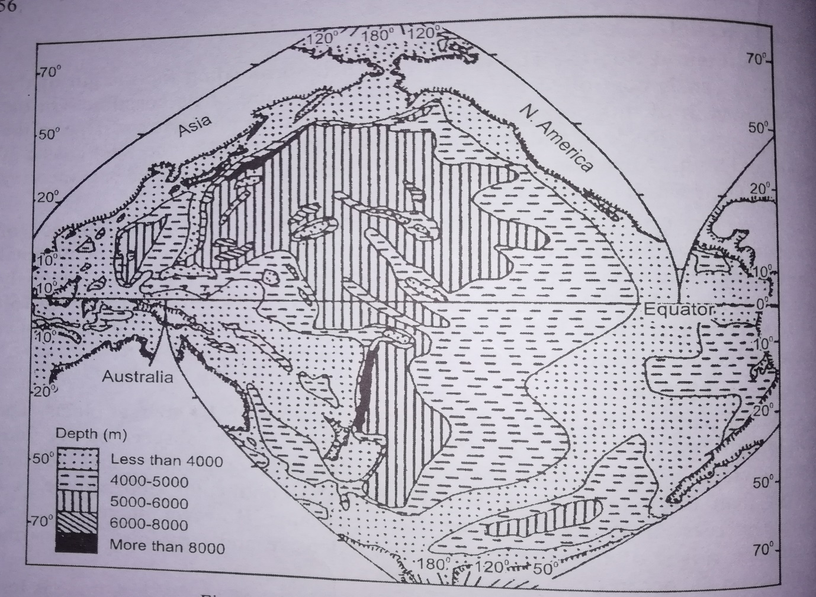
Fig. 1. Bottom relief of the Pacific Ocean
Deeps
Total 32 deeps are recorded in the Pacific, out of which most of them ae in the trenches (longitudinal deep areas), parallel to the island arc or the mountain chain. These deeps are located mostly in the western part of the ocean. The following are some of the important deeps and trenches:
- Aleutian trench – it is and arc like depression bordering Aleutian Islands; the average depth is about 6000 m. and the maximum recorded depth is 7679 m.
- Kurile trench and Japan trench – lying parallel to the Japanese Islands, the 8000 m. deep trench extends for 2700 km, and seldom more than 160 km away from the land. In it are situated Vityez deep (10377 m) and Ramapo deep (10374 m).
- Philippine trench. Extending 64 km along the eastern coast of Philippine Islands, this trench records the greatest depth (10497 m) off the island of Mindanao, known as Cape Johnson deep.
- Mariana trench – the Challenger Deep, in the South Pacific’s Marianas Trench, is the deepest known part of the Ocean. It’s bottom lies 10,900 m below the sea level.
- Tonga-Kermadec trench – it is trough like depression extending from north-east to south-west along the Tonga and Kermadec Islands. They ae measured to be 8000 m. deep with 9428 m. Aldrich deep.
- Peru-Chile trench – it is situated along the Andean coast in the form of broken trenches. Batholomew deep 7973 m. located near Antafogsta city.

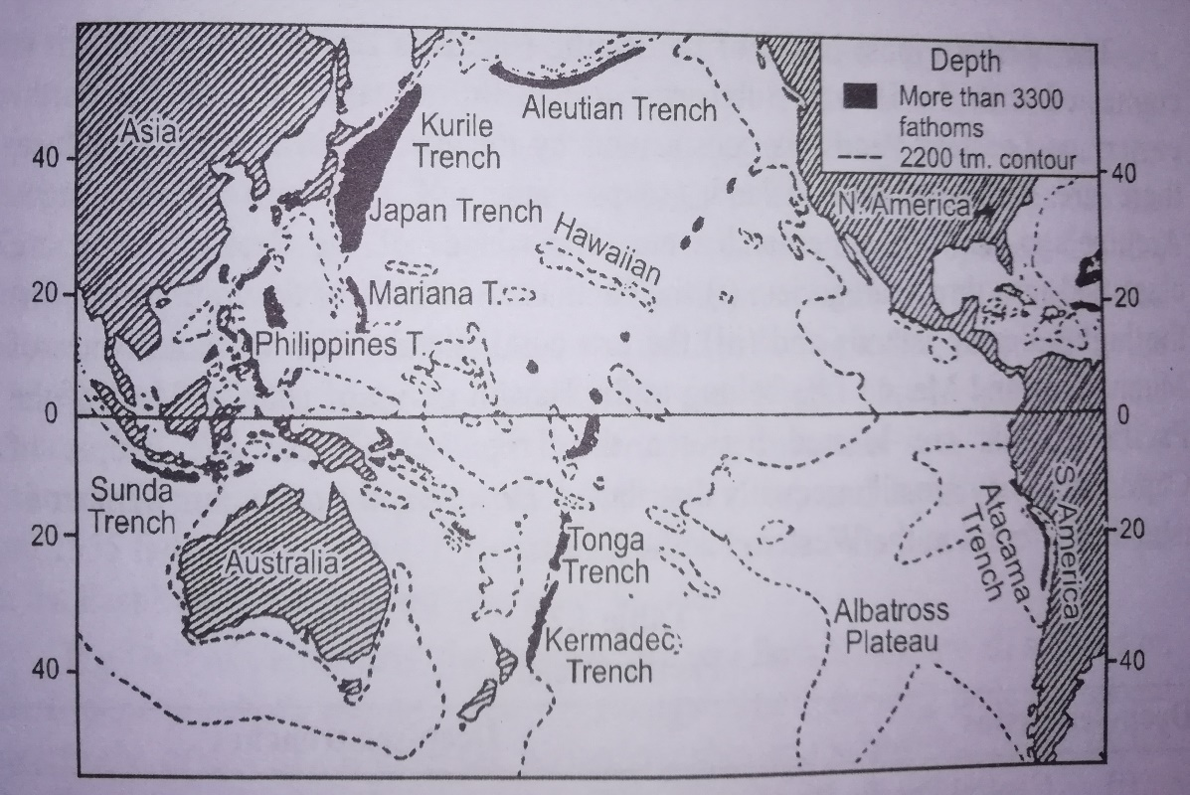
Fig. 2. Pacific Ocean: Ridges and Trenches

