S7U3_2

Principles and Applications of Green Chemistry

1. Introduction
Green chemistry is the design of chemical products and processes that reduce or eliminate the use and generation of hazardous substances. It aims to prevent pollution at the source, rather than treating pollution after it has been produced.
For Earth and Environmental Science students, green chemistry is important because many environmental problems—air and water pollution, hazardous waste, soil contamination, resource depletion, climate change, and ecosystem damage—are closely associated with chemical production and consumption.

Conventional chemistry vs. green chemistry
Conventional approach | Green chemistry approach
Pollution is treated after it is produced | Pollution is prevented at source
Hazardous chemicals may be used | Safer chemicals and processes are preferred
Large quantities of waste may be generated | Waste generation is minimized
Non-renewable resources are commonly used | Renewable resources are encouraged
High energy consumption | Energy-efficient processes
Toxic solvents may be used | Safer solvents or solvent-free processes
End-of-pipe treatment | Pollution prevention
Product performance is the major consideration | Performance + safety + environmental impact

2. The 12 Principles of Green Chemistry
The 12 principles of green chemistry were proposed by Paul Anastas and John Warner. They provide a framework for designing environmentally safer chemical products and processes.

Overview
Prevent → Maximize efficiency → Use safer materials → Save energy → Use renewable resources → Minimize accidents

Principle 1: Prevention of waste
It is better to prevent waste than to treat or clean up waste after it has been created.
Chemical industries should design processes that produce minimum amounts of solid, liquid and gaseous waste.

Environmental significance
- Reduces pressure on landfills.
- Reduces wastewater generation.
- Minimizes air pollution.
- Reduces treatment and disposal costs.
- Protects soil, groundwater and ecosystems.
Example: Designing a chemical reaction with very high conversion and minimal unwanted by-products.

Principle 2: Atom economy
Chemical reactions should be designed so that maximum amounts of the reactant atoms are incorporated into the final product.

Atom economy
Atom Economy (%)=Molecular mass of desired productTotal molecular mass of reactants×100\text{Atom Economy (\%)} = \frac{\text{Molecular mass of desired product}} {\text{Total molecular mass of reactants}} \times100

Example
A reaction producing one desired product and several unwanted by-products has lower atom economy than a reaction in which nearly all reactant atoms become part of the desired product.
Environmental importance:
Higher atom economy → less raw material consumption → less waste.

Principle 3: Less hazardous chemical synthesis
Chemical processes should use and generate substances with little or no toxicity to humans and the environment.
Examples include:
- replacing highly toxic reagents with safer alternatives;
- replacing carcinogenic chemicals where technically possible;
- avoiding persistent and bioaccumulative substances.

Environmental connection
Safer chemicals → lower toxicity → lower ecological risk → healthier ecosystems

Principle 4: Designing safer chemicals
Chemical products should be designed to perform their intended function while reducing toxicity.
For example, a pesticide should control a target pest effectively but ideally:
- degrade after performing its function;
- have low toxicity to non-target organisms;
- have low bioaccumulation potential;
- have minimal persistence in soil and water.
This principle is particularly important in ecotoxicology and environmental risk assessment.

3. Principle 5: Safer solvents and auxiliaries
The use of solvents, separation agents and other auxiliary substances should be avoided where possible.
When their use is necessary, less hazardous alternatives should be selected.

Examples
Conventional solvent/process | Greener alternative
Highly toxic organic solvents | Ethanol or water where technically appropriate
Large solvent volumes | Reduced solvent volume
Organic solvent extraction | Supercritical CO₂ in suitable applications
Solvent-intensive processing | Solvent-free synthesis where feasible

4. Principle 6: Energy efficiency
Energy requirements should be minimized.
Chemical processes should preferably operate at:
- room temperature;
- atmospheric pressure;
- lower temperatures;
- lower pressures;
- shorter reaction times.

Environmental significance
Lower energy consumption can reduce:
Fuel consumption → CO₂ emissions → climate impact
Energy-efficient chemistry therefore contributes to climate-change mitigation.

5. Principle 7: Use renewable feedstocks
Raw materials should preferably come from renewable sources rather than being depleted.

Examples
Renewable resource | Possible application
Vegetable oils | Biodiesel, polymers
Starch | Bioplastics and chemicals
Cellulose | Bio-based materials
Agricultural residues | Bioenergy and chemicals
Algae | Biofuels and biochemical products
However, renewable does not automatically mean sustainable. Land use, water consumption, biodiversity, fertilizer use and life-cycle impacts must also be considered.

6. Principle 8: Reduce unnecessary derivatives
Unnecessary chemical modification such as:
- protection;
- deprotection;
- temporary modification;
should be avoided because these steps often require additional reagents and generate additional waste.

Simplified pathway
Conventional:
Raw material → Protection → Reaction → Deprotection → Product
Greener:
Raw material → Direct reaction → Product
The second route may reduce:
- chemicals;
- energy;
- solvent consumption;
- waste.

7. Principle 9: Catalysis
Catalytic reagents are preferred over stoichiometric reagents.
A catalyst increases the rate of a chemical reaction without being consumed in the overall reaction.

Why catalysts are important
They can:
- reduce energy requirements;
- improve selectivity;
- increase reaction efficiency;
- reduce unwanted by-products;
- reduce raw-material consumption.

Examples
- Enzymes in biotechnology
- Metal catalysts
- Heterogeneous catalysts
- Photocatalysts

Environmental application
Photocatalytic degradation of pollutants can be used for treatment of contaminated water and air.

8. Principle 10: Design for degradation
Chemical products should be designed so that, after completing their intended function, they break down into harmless substances.
This is particularly important for:
- pesticides;
- detergents;
- pharmaceuticals;
- plastics;
- industrial chemicals.

Example
A biodegradable chemical:
Product use → degradation → simpler harmless substances
rather than:
Product use → persistence → accumulation → ecological effects

9. Principle 11: Real-time analysis for pollution prevention
Analytical methods should be developed to allow real-time monitoring and control of chemical processes before hazardous substances are formed.

Examples
- Online sensors
- Continuous air-quality monitoring
- Water-quality sensors
- Process-control systems
- Spectroscopic monitoring
This shifts environmental management from:
Detect → Treat
to:
Monitor → Predict → Prevent

10. Principle 12: Inherently safer chemistry for accident prevention
Chemical substances and processes should be selected to minimize the possibility of:
- fires;
- explosions;
- toxic releases;
- accidental spills;
- occupational exposure.
Risk can be reduced by considering the intrinsic properties of chemicals and the operating conditions of the process.

11. Relationship among the 12 principles
The principles can be visualized as an integrated system:
Raw materials
↓
Renewable / safer feedstocks
↓
High atom economy
↓
Catalytic and energy-efficient reaction
↓
Minimum waste generation
↓
Safer product
↓
Controlled use
↓
Design for degradation
↓
Reduced environmental impact
This demonstrates an important concept:
Green chemistry attempts to prevent environmental damage during the design and production of chemicals rather than relying primarily on pollution control after the damage has occurred.

12. Major Applications of Green Chemistry

12.1 Waste management
Green chemistry can reduce waste at its source.

Applications
- Waste minimization
- Cleaner production
- Solvent recovery
- Recycling of process materials
- Conversion of waste into useful products
- Development of biodegradable materials

Environmental benefit
Less chemical waste → less landfill disposal → less soil and groundwater contamination

12.2 Water pollution control
Green chemistry has applications in preventing and treating water pollution.

Examples
- Biodegradable detergents
- Low-toxicity pesticides
- Green coagulants
- Membrane-based treatment
- Photocatalytic degradation
- Advanced oxidation processes
- Enzyme-based pollutant degradation

12.3 Air pollution reduction
Green chemistry can reduce emissions by modifying chemical processes.

Applications
- Low-emission industrial processes
- Cleaner fuels
- Catalytic converters
- Carbon-efficient chemical synthesis
- Replacement of volatile organic compounds
- Improved industrial process control

12.4 Agriculture
Agriculture uses large quantities of fertilizers, pesticides and other chemicals.
Green chemistry can contribute through:
- biodegradable pesticides;
- controlled-release fertilizers;
- biopesticides;
- pheromone-based pest management;
- plant-derived pesticides;
- precision application of agrochemicals.

Environmental benefit
Reduced:
Chemical input → soil contamination → runoff → eutrophication → ecological damage

12.5 Green solvents
Solvents can constitute a major portion of the material used in some chemical processes.
Research therefore focuses on alternatives such as:
- water;
- ethanol;
- supercritical carbon dioxide;
- certain ionic liquids;
- bio-based solvents.
The choice depends on toxicity, persistence, energy requirements, recyclability and overall life-cycle impacts.

12.6 Pharmaceutical industry
Green chemistry can make pharmaceutical manufacturing more sustainable by:
- reducing solvent consumption;
- improving reaction efficiency;
- using catalysts;
- reducing reaction steps;
- increasing atom economy;
- reducing hazardous intermediates.

General pathway
Conventional pharmaceutical synthesis
Many reaction steps
↓
High solvent use
↓
High waste generation
↓
Greater environmental burden
Green approach
Fewer steps
↓
Catalysis
↓
Safer solvents
↓
Higher efficiency
↓
Lower waste

12.7 Green chemistry and energy
Green chemistry contributes to sustainable energy technologies through:
- battery materials;
- fuel cells;
- solar-cell materials;
- hydrogen production;
- biofuels;
- carbon capture and utilization;
- energy-efficient chemical processes.

12.8 Plastics and polymers
Conventional plastics may persist in the environment for long periods.
Green chemistry approaches include:
- biodegradable polymers;
- bio-based polymers;
- recyclable polymers;
- polymers designed for chemical recovery;
- reducing hazardous additives.
Examples include PLA (polylactic acid) and other bio-based polymer systems, although their sustainability must be assessed using life-cycle analysis.

13. Green Chemistry and Earth & Environmental Science
Environmental issue | Green chemistry approach | Expected environmental benefit
Water pollution | Safer chemicals, biodegradable products | Reduced aquatic toxicity
Air pollution | Cleaner processes and catalysts | Reduced emissions
Soil contamination | Safer pesticides and chemicals | Reduced soil toxicity
Hazardous waste | Waste prevention | Less hazardous waste
Climate change | Energy-efficient chemistry | Lower energy-related emissions
Resource depletion | Renewable feedstocks | Reduced dependence on finite resources
Plastic pollution | Biodegradable/recyclable materials | Reduced persistence
Occupational hazards | Safer chemicals and processes | Reduced exposure
Ecosystem toxicity | Safer product design | Reduced ecological risk
Industrial accidents | Inherently safer processes | Lower accident potential

14. Green Chemistry vs. Green Engineering
These concepts are related but not identical.
Green Chemistry | Green Engineering
Focuses primarily on chemical substances and reactions | Focuses on design of processes and systems
Minimizes hazardous substances | Minimizes environmental impacts of engineered systems
Emphasizes safer molecules | Emphasizes safer and efficient processes
Atom economy is important | Energy and material efficiency are important
Catalysis is important | Process optimization is important
Designing safer chemicals | Designing sustainable systems
Together they support sustainable production.

15. Green Chemistry vs. Conventional Pollution Control

Conventional approach
Raw materials → Production → Waste → Treatment → Disposal
This is often called an end-of-pipe approach.

Green chemistry approach
Safer raw materials → Efficient reaction → Minimum waste → Safer product
The major conceptual difference is:
Pollution control manages pollution after it has been generated; green chemistry seeks to prevent its generation in the first place.

16. Important Green Chemistry Metrics
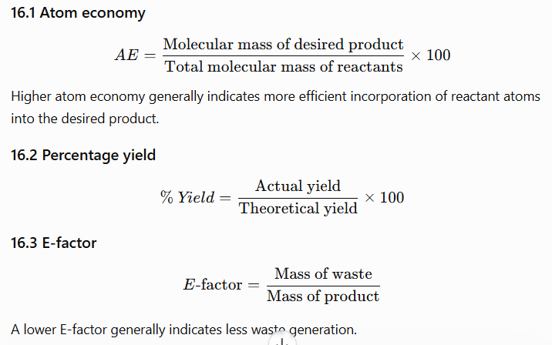

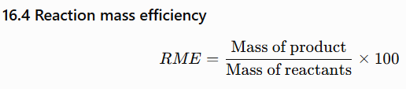
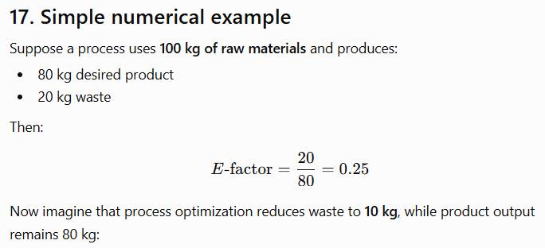


18. Applications in Environmental Biotechnology
Green chemistry and environmental biotechnology are closely connected.

Examples
Microbial degradation
Organic pollutant
↓
Microorganisms
↓
Enzymatic breakdown
↓
Less complex compounds
↓
CO₂ + H₂O + biomass
(depending on the pollutant and environmental conditions)

Applications
- Bioremediation
- Wastewater treatment
- Composting
- Anaerobic digestion
- Enzyme-based treatment
- Biodegradation of hydrocarbons
- Treatment of industrial effluents

19. Case Study: Green synthesis of nanoparticles
Nanoparticles can be synthesized using biological materials such as:
- plant extracts;
- microorganisms;
- enzymes.
Plant extracts may act as reducing and stabilizing agents.

Conventional approach
Chemical reducing agent
→ Nanoparticle synthesis
→ Chemical residues

Green approach
Plant extract / biological material
→ Reduction of metal ions
→ Nanoparticle formation
Potential advantages include reduced use of certain hazardous reducing agents, although nanoparticle toxicity and environmental fate must still be assessed.

20. Case Study: Green pesticide design
A conventional pesticide may have:
- high persistence;
- toxicity to non-target organisms;
- bioaccumulation potential.
A greener pesticide can be designed to:
- target specific pests;
- work at lower concentrations;
- degrade after application;
- have reduced toxicity to non-target organisms.
This illustrates the connection between green chemistry, ecotoxicology and environmental health.

21. Green Chemistry and Sustainable Development
Green chemistry supports several broad sustainability objectives:
Resource efficiency
↓
Pollution prevention
↓
Safer products
↓
Reduced environmental risk
↓
Human health protection
↓
Sustainable development
It therefore provides a scientific basis for moving from a linear economy toward a more circular and resource-efficient economy.

